Michael Maranville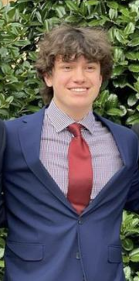

michaelmaranville@yahoo.com

Senior at Frisco High School

University of Texas at Dallas

This year I was the scrum master of the class, on top of coding, I was doing most of the “paperwork” for the project. Things like keeping up with the trello board, making sure everyone is doing their journals, and making sure the fifty pager was ready on time. Coding-wise, I originally started trying to create different movement mechanics for the player, I created a wall climb, a ledge grab, and a mantle. After I spent some time working on the movement mechanics, I then switched over to filling out whatever needed to be done. I worked on a boss fight, I worked on some of the menu systems, just if anyone needed me anywhere I helped them out. For the second half of the year, I spent most of my time working on merging other peoples codes into the game. That took up most of my time as only Jacob and I had controls to merge other people's code into master.